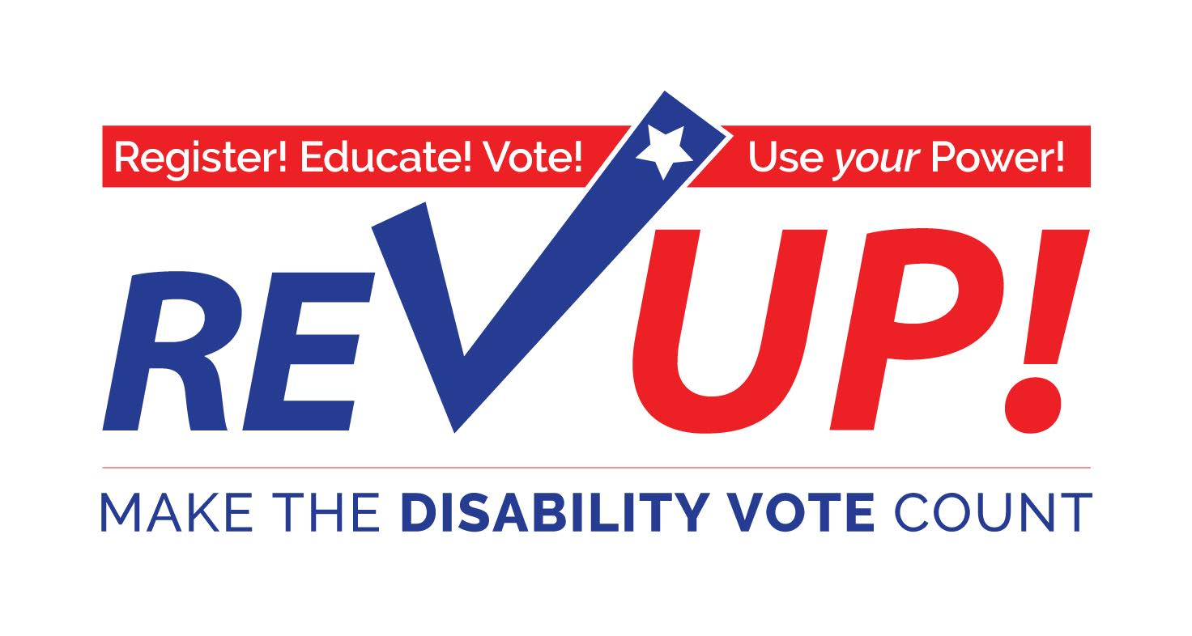

**How to be an Election Worker in [STATE]**

National Disability Voter Registration week has come and gone, and you may be wondering what are the next steps to make people see the power of the disability vote. One way to do this is by making our physical presence known. A great way to remind people that we are part of the community is by working at a polling site!

What does an election worker do exactly? Their primary job is to make sure the voting process (in their precinct) runs smoothly. Their duties can range from verifying a voter’s ID/credentials, giving out ballots, keeping track of all equipment and votes, and making sure all voting laws are followed throughout the entire election process. A great part of being an election worker is that you don’t have to be a government official; the only requirement is that you are a registered voter in the county in which you work.

What’s even better is that you can earn money while doing this! While some counties pay different amounts, the average wage for a poll clerk in the state of Texas, for example, is $8.50 an hour. This is a great work opportunity if you can only work part time hours, are limited to how much money you can earn, are trying to build some job experience, etc.

How do you sign up? First, contact your county elections office and let them know you would like to serve as an election worker. You will have to attend a training for election workers put on by the elections office. Each county may have a different way of doing things, so be sure to ask the election office staff what next steps you need to take.

If you need help finding the election office’s contact information, you should visit the website of the Secretary of State [INSERT WEB LINK TO SOS] in your state to find the contact information for each county’s election office. You can also talk to a staff person at your local independent living center to see if they can help you.

Should you have any more questions about voting, please call the [ORGANIZATION] at [PHONE].